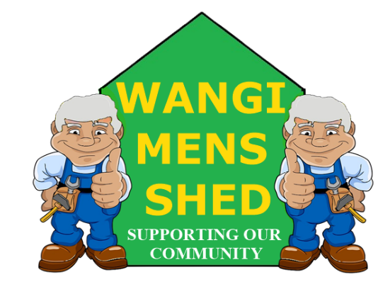
October 2026 Newsletter
  - Connecting Mates, Crafting Purpose

Shed Happenings – A review of the month’s events
The extensions and windbreaker screen at the rear of the shed have been completed. Not only do we now have extra undercover and secure storage, but the overall appearance and access have also been improved.
A highly informative article in the Newcastle Herald highlighting the restoration of the old mining model of Barry Grant’s by the shed’s own Neville Thorogood (once again highlighting what our shed is capable of).
Another successful Morisset BBQ by Maurice and the crew, including the first showing of our new table cover and logo, which, by all accounts, was well received.
The predicted rain that caused us to postpone the Garage Sale did not occur (Mother Nature does not follow the weather report it seems). The re-scheduled sale, however, was very well attended by the community and provided a good outcome for our Shed.

Member Mentions
A huge thanks to all members who contributed to the annual garage sale (especially those who turned up early to help with the set-up). Special mention to Michael Darlington and Peter Sreet for also manning the Tattoo Curiosities BBQ on the same day.

Upcoming Events
- Next Bunnings BBQ Morisset Saturday 21st November.
- AGM Tuesday 24th November.
- Xmas Shutdown - Close: 14th December 2026, Re-Open: 11th January 2027.

Health & Wellbeing

Always keep in sight of why Men’s Sheds exist. Our primary purpose is to support the health and wellbeing of our members while making a positive contribution to the wider community.

Everything we do, whether it’s woodworking, restoring equipment, sharing skills, or simply having a cuppa and a chat we should always focus on maintaining a welcoming place for all where we can connect, find purpose, and look after one another.

Shed Humour
This one’s for Harry.
Donald Trump walks into a Bank of America to cash a cheque. As he approaches the cashier he says, "Good morning, Ma'am, could you please cash this cheque for me?"
Cashier: "It would be my pleasure sir. Could you please show me your ID?"
Trump: "Truthfully, I did not bring my ID with me as I didn't think there was any need to. I am Donald Trump, former President of the United States.
Cashier: "Yes sir, I know who you are, but with all the regulations and monitoring of the banks because of impostors and forgers and requirements of the regulators, etc. I must insist on seeing ID."
Trump: "Just ask anyone here at the bank who I am and they will tell you. Everybody knows who I am."
Cashier: "I am sorry, Mr. Trump, but these are the bank rules and I must follow them."
Trump: "Everybody in the world knows me. I am urging you, please, to cash this cheque."
Cashier: "Look Mr. Trump, here is an example of what we can do. One day, Tiger Woods came into the bank without ID. To prove he was Tiger Woods he pulled out his putter and made a beautiful shot across the bank into a cup. With that shot we knew him to be Tiger Woods and cashed his cheque.
Another time, Andre Agassi came in without ID. He pulled out his tennis racket and made a fabulous shot whereas the tennis ball landed in my cup. With that shot we cashed his cheque.
So, Mr. Trump, what can you do to prove that it is you, and only you?"
Trump stands there thinking, and thinking, and finally says,
"Despite my Great, Unmatched Wisdom, honestly, my mind is a total blank. There is nothing that comes to my mind. I can't think of a single thing. I have absolutely no idea what to do and I don't have a clue."
Cashier: "Will that be large or small bills, Mr. Trump?"

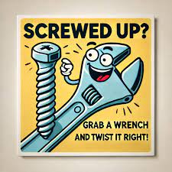

Our Shed is more than just a workshop—it is a family. Every project, cup of tea or coffee, and story shared is a testament to the strength of our community. Until next month—stay safe, stay connected, and keep building!

