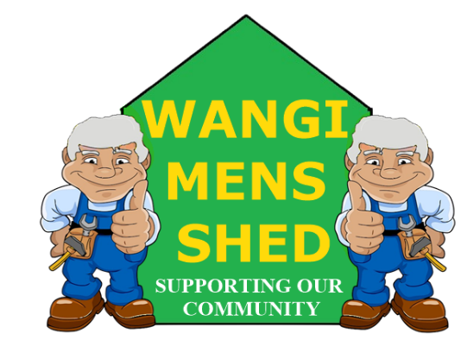
September 2026 Newsletter
  - Connecting Mates, Crafting Purpose

Shed Happenings
The Aboriginal School Community Event BBQ for NAIDOC week was well attended and, by all reports, the children behaved very well.
The construction of the new storage area at the back of the shed and the windbreak is proceeding on schedule and will hopefully be ready by months end.
A huge vote of thanks was received from Dora Creek Public School for the completion of their GAGA Pit. The students are loving it!
Getting all the Garage Sale items down from storage commenced and the sorting and setting up will continue until the sale date.

Upcoming Events
- Next Bunnings Morisset Saturday 24th October.
- Annual Garage Sale, Saturday 17th October
- Tattoo Curiosities BBQ Saturday 31st October.

Member Mentions
Special thanks to all the members who gave up their own time to man the Aboriginal School Community Event at BBQ Wyee on Friday 18th October. Your efforts are greatly appreciated.
Those who raised their hands to assist in the last-minute Bunnings Morisset BBQ also deserve to be commended. BBQs are probably our most important income source, and more members need to raise their hands and get involved.

Health & Wellbeing
September was Prostate Cancer awareness month. Get yourselves checked. A simple blood test could save your life. Some of us have already been there and, if caught early, the prognosis is generally positive.

Workshop Safety
The importance of Safety tags has once again been raised; they are there for a reason. Proper understanding of their use is especially important to both protect you and the machinery. Please read the document located above the tag storage area for their appropriate use or consult a relevant supervisor if still unsure.

New Members
Welcome to Ladislav (Les) Safarik, Scott Greentree, Bjorn Lategan, Stephen [Drinky) Drinkwater. Don Brown, and Bernard (Bernie) Saunders. Whether you are experienced or just starting out, you belong here. Feel free to introduce yourself and get involved in our Shed community.

Shed Humour (Contributed by Ray Dawkins)
A young jackaroo from outback Queensland goes off to university, but halfway through the semester he foolishly has squandered all of his money. He calls home. "Dad," he says, "you won't believe what modern education is developing. They have a program here in Brisbane that will teach our dog Ol' Blue how to talk." "That's amazing!" his Dad says. "How do I get Ol' Blue in that program?" "Just send him down here with $2,000," the young jackaroo says, "I'll get him in the course." So, his father sends the dog and $2,000. About two-thirds through the semester, the money again runs out. The boy calls home. "So, how's Ol' Blue doing, son?" his father wants to know. "Awesome! Dad, he's talking up a storm. But you just won't believe this. They've had such good results with talking, they've begun to teach the animals how to read." "Read?!" exclaims his father. "No kidding! How do we get Ol' Blue in that program?" "Just send $4,500. I'll get him in the class." The money promptly arrives. But our hero has a problem. At the end of the year, his father will find out the dog can neither talk nor read. So, he shoots the dog. When he arrives home at the end of the year, his father is excited. "Where's Ol' Blue? I just can't wait to talk with him and see him read something!" "Dad," the boy says, "I have some grim news. Yesterday morning, just before we left to drive home, Ol' Blue was in the living room, kicked back in the recliner, reading the Financial Review. Then he suddenly turned to me and asked, 'So, is your daddy still messing around with that redhead barmaid at the pub?'"
The father groans and whispers, "I hope you shot that bastard before he talks to your mother!"
"I sure did, dad!"………… "That's my boy!"
The kid went on to be a successful lawyer.

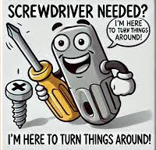

Our Shed is more than just a workshop—it is a family. Every project, cup of tea or coffee, and story shared is a testament to the strength of our community. Until next month—stay safe, stay connected, and keep building!

