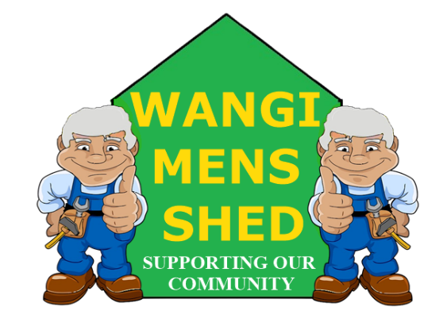
August 2026 Newsletter
  - Connecting Mates, Crafting Purpose

Shed Happenings
Yet another Eraring BBQ, this time for NAIDOC week (supposedly). Apparently, they are very fond of our catering skills.
We have had quite a few donations this month which will come in handy for our upcoming garage sale. Several members have also contributed their own projects.
The NovaCare aged care presentation on the 18^{th of} August was well received, and the BBQ beforehand went down well.
The fume extraction system for the metalworking area has been acquired. Just need to install it now.

Upcoming Events
- Next Bunnings Morisset Saturday 24th October.
- Toronto Light Rail BBQ, Sunday 27th September (Tentative).
- Annual Garage Sale, Saturday 17th October

Member Mentions
As you may be aware David Tonkin has decided to retire as Treasurer due to ill health. Mark Carson has been elected to take over the role. Special thanks to Greg and Peter for giving up their own time to travel to Sydney to pick up the fume extractor.

Health & Wellbeing
Kidney Health Week was a reminder to take the piss seriously.
Because the scary part about kidney disease? It can creep up without making much noise.
Your kidneys do a hell of a lot more than most people give them credit for. They filter waste, balance fluids, and help keep your body running properly. Literally.
A few things worth remembering:

- Drink your water.
- Get your blood pressure checked.
- Know your kidney health and get tested if you’re at risk.
- And yes, pay attention to your pee.
Your kidneys work around the clock. It’s time to start looking after them.

Workshop Safety
You must receive proper instructions on how to use any machinery correctly before operation. PLEASE CONTACT ALAN JONES TO ARRANGE THE NECESSARY TRAINING.
Do not use any machinery, tools, or equipment with an “OUT OF SERVICE TAG.” It is there for a reason: to protect both you and the equipment.
Safety is everyone’s responsibility. Before starting any project, double-check that all tools are in good working order and you are wearing the proper protective gear. Our safety signage should make it easy to remember, but if you are unsure—ask!

New Members
Welcome to returning member Michael (Mike) Dentist who is interested in learning welding and building things. Whether you are experienced or just starting out, you belong here. Feel free to introduce yourself and get involved in our Shed community.

Shed Humour
A married man was having an affair with his secretary. One day, their passions overcame them in the office, and they took off for her house. Exhausted from the afternoon's activities, they fell asleep and awoke at around 8 p.m. As the man threw on his clothes, he told the woman to take his shoes outside and rub them through the grass and dirt. Confused, she nonetheless complied and he slipped into his shoes and drove home. "Where have you been?" demanded his wife when he entered the house. "Darling," replied the man, "I can't lie to you. I've been having an affair with my secretary. I fell asleep in her bed and didn't wake up until eight o'clock." The wife glanced down at his shoes and said, "You liar! You've been playing golf!"

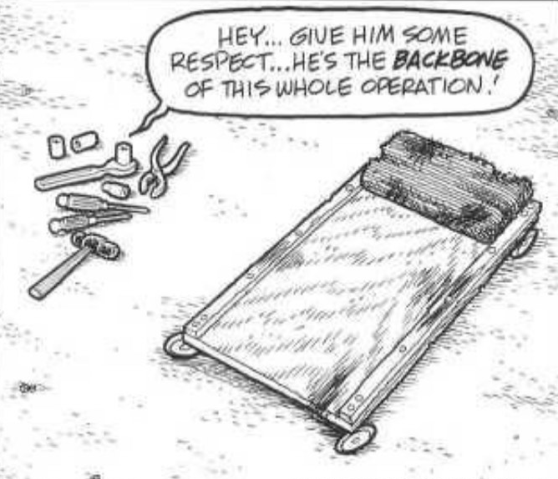
Our Shed is more than just a workshop—it is a family. Every project, cup of tea or coffee, and story shared is a testament to the strength of our community. Until next month—stay safe, stay connected, and keep building!

