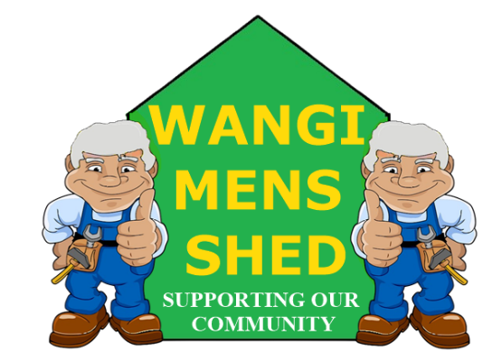
July 2026 Newsletter
  - Connecting Mates, Crafting Purpose

A busy start to the month with the Eraring Battery BBQ. Thanks again to Origin Energy for their ongoing support. We also received many customer and community projects to keep us occupied (and provide income). Much as we like to give back to the community, our shed needs to be able to pay its own way, so every little bit helps.

Shed Happenings

Bayswater Street Library project has been completed and delivered.
- Eraring Battery BBQ went well as usual and was much appreciated.
- Cleanup of back area in preparation for installation of an extra shed and racking is ongoing.

Upcoming Events
- NovaCare aged care presentation. Tuesday 18th August 10:10am.
- Morisset Bunnings BBQ, Saturday 22nd August.
- Toronto Light Rail BBQ, Sunday 27th September (Tentative).
- Annual Garage Sale 17th October (Tentative).

Health & Wellbeing
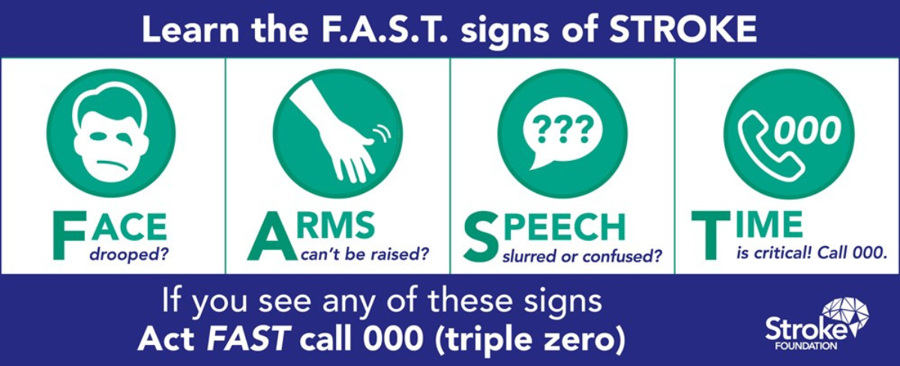
Knowing these signs and acting without hesitation could save the life of a mate, family member, workmate, or neighbour.

Workshop Safety
You must receive appropriate instructions on how to use any machinery correctly before operation. PLEASE CONTACT ALAN JONES TO ARRANGE THE NECESSARY TRAINING.
Do not use any machinery, tools, or equipment with an “OUT OF SERVICE TAG.” It is there for a reason: to protect both you and the equipment.
Safety in the workshop does not only involve machinery, but the environment we work in also plays a significant role. Be it noise, fumes, or untidiness if you have a concern, please raise it with your relevant supervisor.

New Members
Welcome to Michael (Mike) Dentist. Whether you are experienced or just starting out, you belong here. Feel free to introduce yourself and get involved in our Shed community.

Shed Humour
Points to ponder. Contributed by Oscar Shahinian
If a bottle of poison reaches its expiration date, is it more poisonous or is it no longer poisonous?
- Do twins ever realize that one of them is unplanned?
- Every time you clean something, you just make something else dirty.
- Over 100 years ago, everyone owned a horse and only the rich had cars. Today everyone has cars and only the rich own horses.
- As I've grown older, I've learned that pleasing everyone is impossible, but ticking everyone off is a piece of cake!
- My tolerance for idiots is extremely low these days. I used to have some immunity built up, but obviously, there is a new strain out there.
- As I've gotten older, people think I've become lazy. The truth is I'm just being more energy efficient.
- There is no such thing as a grouchy old person. The truth is that once you get old, you stop being polite and start being honest.
- My wife says I keep pushing her buttons. If that were true, I would have found mute by now.
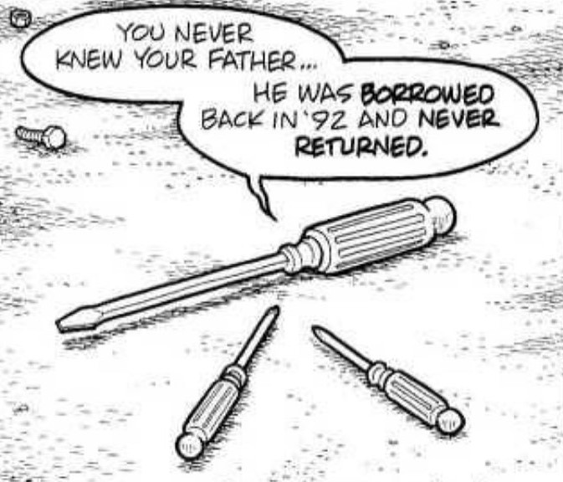

Our Shed is more than just a workshop—it is a family. Every project, cup of tea or coffee, and story shared is a testament to the strength of our community. Until next month—stay safe, stay connected, and keep building!

