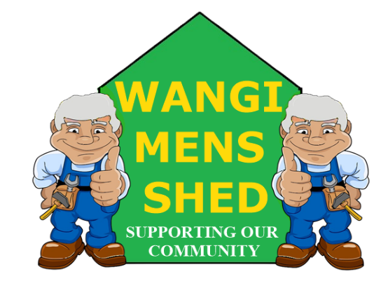
June 2026 Newsletter
  - Connecting Mates, Crafting Purpose

Early start to the month with the setup (and disassembly) of the display stands for the Dobel Arts Festival at Wangi Workers Club. Appreciation to everyone who contributed. Unfortunately, the BBQ for the Toronto Light Rail had to be postponed until later this year over attendance and weather concerns.

Shed Happenings

The large Panel Saw has been professionally setup by the manufacturer’s agent. It is important to note that no adjustments are to be made on this machine.

Treated pine sleepers for the Dora Creek School Fuzz Ball (also known as Dodge Ball) Pit have been cut to requirements and delivered. Our Shed is providing garden tools so as the students can prepare the ground for its installation (should be interesting).

Work has begun on the Bayswater Street Library project. Design and size have been left up to us, with just a few requests for basic requirements. Thanks to Charles Camilleri for supervising the construction.

- Another fantastic donation of medical, PPE and other supplies from Wambo Coal (Glencore). Peter Scroope is to be congratulated for his procuring skills.

Upcoming Events
- Eraring Battery BBQ, Thursday 2nd July.
- Toronto Light Rail BBQ, Sunday 27th September (Tentative).
- Annual Garage Sale October (Date to be confirmed).

Member Mentions
We extend our sincere condolences to Harry Gardner on his recent loss. Our shed is here to support you on this difficult time.
Great to see our President/Treasurer back at the shed after his long hospitalisation, he has been missed. (Poor bugger has a lot of work to catch up on!).

Health & Wellbeing
Men’s Health Week in June is an important reminder that looking after your health is one of the most important things you can do for yourself, your family, and your community. The reality is that too many Australian men are putting off getting the help they need. Despite experiencing higher rates of chronic disease, preventable illness and premature death, many men continue to delay seeking medical care. Looking after your health is not a sign of weakness it is one of the strongest things you can do.

Workshop Safety
You must receive appropriate instructions on how to use any machinery correctly before operation. PLEASE CONTACT ALAN JONES TO ARRANGE THE NECESSARY TRAINING.
Do not use any machinery, tools, or equipment with an “OUT OF SERVICE TAG.” This tag protects you and the equipment.
Safety is everyone’s responsibility. Before starting any project, double-check that all tools are in good working order and you are wearing the appropriate protective gear. Our safety signage should make it easy to remember, but if you are unsure—ask!

New Members
Welcome to Eckhard Platen. Whether you are experienced or just starting out, you belong here. Feel free to introduce yourself and get involved in our Shed community.

Shed Humour
Two guys are working at a sawmill when—WHAM! —one of them gets too close to the blade and chops off his arm. His friend grabs the severed limb, shoves it in a plastic bag, and rushes him to the hospital. The next day, he visits his friend and finds him casually playing tennis. “Incredible!” he says. “Medical science is amazing!”
A month later, same sawmill, same two guys—WHAM! —this time, the poor guy’s leg gets lopped off. Once again, his friend scoops it up, bags it, and hauls him to the hospital. The next day, he stops by to check in and finds his friend outside playing football.
“Incredible!” he says. “Medical science is amazing!”
Another month goes by, and wouldn’t you know it—WHAM! —this time, the guy bends too close, and off comes his head. His friend sighs, shoves it in a plastic bag, and rushes to the hospital one more time. The next day, he arrives to visit his friend—but he is nowhere to be found. He spots the doctor and asks, “Hey, Doc, where is my friend? I brought him in yesterday.”
The doctor shakes his head. “Oh yeah… some idiot put his head in a plastic bag, and he suffocated.”

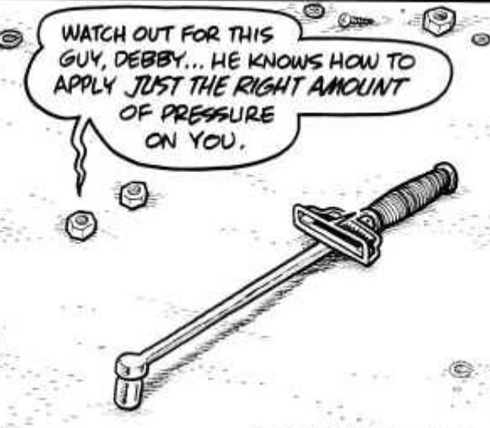

Our Shed is more than just a workshop—it is a family. Every project, cup of tea or coffee, and story shared is a testament to the strength of our community. Until next month—stay safe, stay connected, and keep building!

