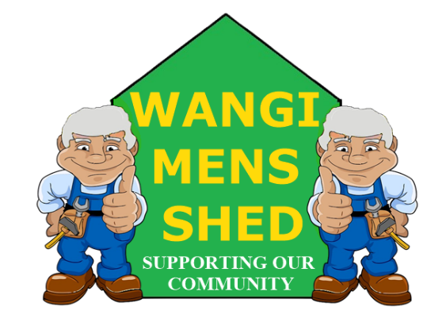
May 2026 Newsletter
  - Connecting Mates, Crafting Purpose

The month began with a hectic schedule, featuring both the Bunnings Morisset and Wangi Fire Station BBQs on the same day, followed by the Rathmines Public School event later in the month. Thank you to everyone who contributed to the success of these events. The results from the Solar Backup batteries have been promising so far, even with the overcast conditions.

Shed Happenings

The large Panel Saw has been donated to South lakes Mens Shed.

The three wood lathes have been sold (thanks to Peter Scroope).

The huge bandsaw has been donated to a Taree timber yard.

The old 3 Phase MIG welder has been donated to Redhead Mens Shed.

Upcoming Events
- Bunnings Morisset BBQ, Saturday 20th June.
- Lake Macquarie Light Rail BBQ, Sunday 21st June.

Member Mentions
We extend our sincere appreciation to Peter Jackson for his continued efforts in electrical maintenance, which ensure that our shed remains safe and properly illuminated. David Tonkin’s condition continues to improve, his spirit has returned, and the latest news is that he can’t wait to get back to the shed.
* Reminder that membership renewal fees ($50) are due by 30th June 2026. *

Health & Wellbeing
Far too many men lose their lives prematurely to issues that can be addressed, such as suicide, heart disease, cancer, diabetes, obesity, loneliness, or delaying help until it’s almost too late. Everyone needs support at times—whether from a friend, family member, doctor, counsellor, local group, community shed, walking club, fatherhood program, or simply someone who’ll listen without judgment. Caring for your health goes beyond occasional gym visits or eating salads; it also means regularly checking in on yourself and others, making that call to the doctor, having tough conversations, and seeking assistance before things unravel.

Workshop Safety
You must receive appropriate instructions on how to use any machinery correctly before operation. PLEASE CONTACT ALAN JONES TO ARRANGE THE NECESSARY TRAINING.
Do not use any machinery, tools, or equipment with an “OUT OF SERVICE TAG.” This tag protects you and the equipment.
The necessity of wearing/using the correct PPE has again risen after an accident occurred when a member was splitting kindling. The resulting injury required a visit to the doctor and some stitches. Wearing the appropriate PPE will not stop accidents, but it will usually limit the severity of the injury.

Shed Humour
Missionary’s English Lesson
After years spent helping a tribe become self-sufficient through teaching them farming and construction skills, a missionary receives word that it is time for him to return home. Reflecting on his work, he realises he has never taught the natives how to speak English. Determined to remedy this, he decides to begin with the tribe’s chief and takes him for a walk in the forest.
Pointing to a tree, the missionary says, “This is a tree.” The chief observes the tree and responds, “Tree.” Encouraged by the chief’s quick grasp, the missionary continues. They walk further and the missionary points to a rock, stating, “This is a rock.” The chief looks and says, “Rock.” The missionary becomes increasingly enthusiastic about the chief’s progress.
Suddenly, a rustling sound comes from the bushes. The missionary peers over to discover a couple engaged in enthusiastic romantic activity. Flustered, he tries to divert attention and blurts out, “Riding a bike.” The chief briefly observes the couple, then pulls out his blow gun and kills them both. Shocked and upset, the missionary confronts the chief, reminding him of all the years spent teaching the tribe to be civilised and kind. He asks how the chief could commit such an act. The chief simply replies, “My bike.”

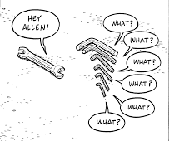

Our Shed is more than just a workshop—it is a family. Every project, cup of tea or coffee, and story shared is a testament to the strength of our community. Until next month—stay safe, stay connected, and keep building!

