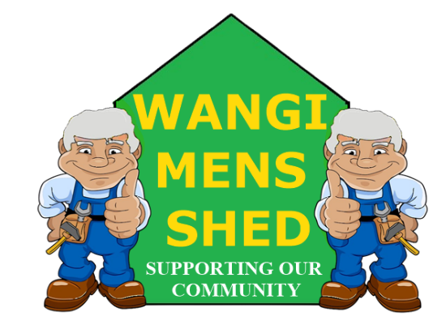
March 2026 Newsletter
  - Connecting Mates, Crafting Purpose

This month, activity at the shed has been relatively steady, with various personal projects in progress alongside ongoing customer renovations and repairs. Furthermore, preparations are being made to organise the rear section and optimise management of the timber stockpile. Also investigating options of adding extra enclosed storage for BBQ equipment etc.

Shed Happenings

The Dora Creek Public School Athletics Carnival took place at Wangi Oval, with Wangi Mens Shed serving as host and providing barbecue and refreshments. A good day for all concerned.
- Morisset BBQ started out a bit quiet but picked up later with a better-than-expected outcome.
- Wyee School Sports Carnival BBQ was another success. We cooked and the staff served.

Upcoming Events
- Bunnings Glendale BBQ, Sunday 12th April.
- Eraring Battery BBQ, Thursday 16th April.

Member Spotlight
Thanks to all the members involved for their effort in getting all the new shed set-up organised. Your efforts are greatly appreciated.

Health & Wellbeing
Do you know the biggest threats to men's health? Heart disease and cancer top the list. Others include injury, lung disease, stroke and diabetes. Although you may not be able to prevent all of these, some can be prevented. Healthy lifestyle choices, such as eating a healthy diet and moving every day, can help.

And take steps to keep yourself safe. Use a seat belt when in a car. Wear a helmet when on a bike or motorcycle. Use a safety ladder to reach high areas. Manage illnesses such as high blood pressure, diabetes and high cholesterol. Get all the suggested health screenings and vaccinations for your age.

Workshop Safety
You must receive appropriate training on how to use any machinery correctly before operation. PLEASE CONTACT ALAN JONES TO ARRANGE THE NECESSARY TRAINING.
Do not use any machinery, tools, or equipment with an “OUT OF SERVICE TAG.” This tag protects you and the equipment.
Today's safety reminder: Stay vigilant and exercise caution whenever using cutting tools. Before making any cuts, carefully consider the procedure to identify potential risks and prevent unsafe practices.
New Members Welcome!

Wangi Mens Shed are pleased to have onboard David Harnett, Bill Hughes, Desmond Wild, Karel Nejedly and Frank Haley. Whether you are experienced or just starting out, you belong here. Feel free to introduce yourself and get involved in our Shed community.

Shed Humour

A drunk, who reeked of booze got on a train, and sat facing a vicar. The drunk’s tie was stained, his face was covered in lipstick, and a half empty whiskey bottle was hanging from one of his pockets. He opened a newspaper and started to read it. After a short while, the man asked the priest, "Tell me father, what causes arthritis?". The priest replies, "My son, it is caused by loose living, being with cheap, wicked women, too much liquor, contempt for your fellow man, sleeping around with prostitutes, and a lack of bathing". The drunk looked up in surprise and said, "Well I'll be dammed", and then continued reading his newspaper. The priest reflected for a while on what he had said, and he tapped the drunk on the shoulder, and apologised.

"I'm very sorry. I didn't mean to come on so strong. How long have you had Arthritis?".

The drunk replied, "I don't have it father, I had just read in the paper that the Pope has it".

Moral of the Story... Make sure you understand the question, before offering the answer...!!
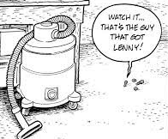
Our Shed is more than just a workshop—it is a family. Every project, cup of tea or coffee, and story shared is a testament to the strength of our community. Until next month—stay safe, stay connected, and keep building!

