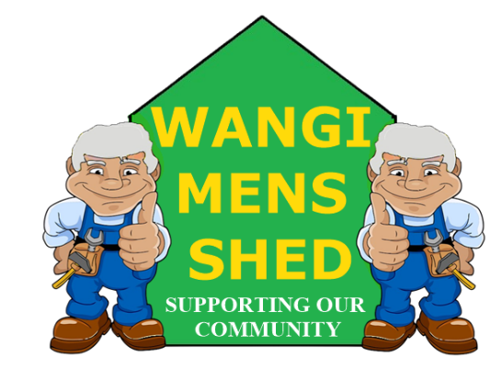
April 2026 Newsletter
  - Connecting Mates, Crafting Purpose


April stands out as a notably distinctive month within the Australian calendar. It begins with traditional observances of April Fools’ Day, marked by playful pranks and unusual stories, and concludes with the solemn commemoration of ANZAC Day on the 25th, which honours the service and sacrifice of military personnel.

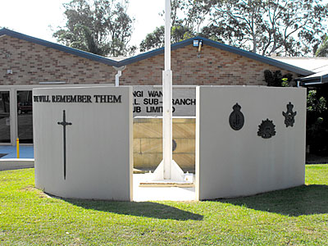
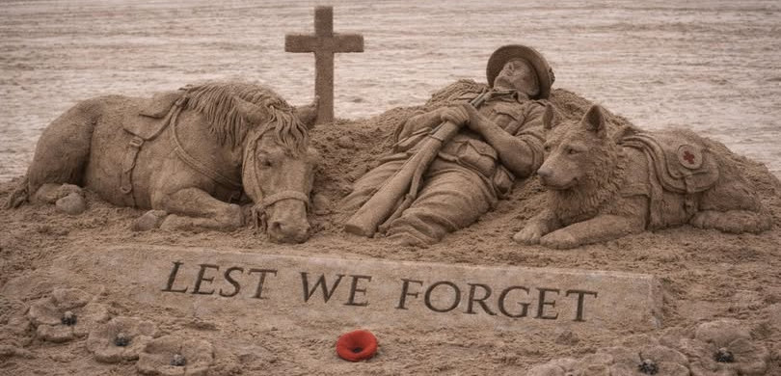

Shed Happenings

A nice donation for the Shed received from Vivcourt Trading.
- Glendale BBQ was an immense success, another great earner for the Shed.
- Eraring Battery BBQ luncheon on Thursday 16th April went down extremely well.
- Installation of the Solar Batteries; a large investment but will return profit for the shed in the long term.

Upcoming Events
- Bunnings Morisset BBQ, Saturday 9th May.
- Lake Macquarie Light Rail BBQ, Sunday 21st June.

Member Mentions
Special appreciation to Greg Cross for the time and effort he has put in to organising the Solar Batteries for the shed. Our thoughts and best wishes to our president and treasurer David Tonkin who is currently undergoing treatment in hospital.

Health & Wellbeing
Feeling exhausted and your flat white isn’t touching the sides? Fatigue is a feeling of tiredness or lack of energy that doesn’t go away, even when you rest. You can feel physically fatigued, psychologically fatigued or both. Most of the time low energy is caused by one or more of your habits or life circumstances. But in some cases, fatigue can be a symptom of an underlying medical problem that needs treatment. See your doctor if you have fatigue for more than 2 weeks and it is not getting better.
Fatigue makes you feel mentally and/or physically exhausted and reduces your ability to work safely and effectively.

Workshop Safety
You must receive appropriate instructions on how to use any machinery correctly before operation. PLEASE CONTACT ALAN JONES TO ARRANGE THE NECESSARY TRAINING.
Do not use any machinery, tools, or equipment with an “OUT OF SERVICE TAG.” This tag protects you and the equipment.
A near miss in the metal working section when the bending machine fell over whilst attempting to move it, narrowly missing one of our more experienced members (it has since been securely bolted to the floor). A reminder to all to not automatically assume things are safe: Check first and, if in doubt, ask for assistance.

Shed Humour
April the first turned out to be a letdown for the inaugural flight of BUNNINGS AIRWAYS. The offer of beating existing fares by 10% was well received but ventilation for the on-board sausage sizzle proved to be a problem. Apparently, opening all the doors at 10,000 meters was not a good idea.
On the same day, the introduction of a 3D printed hamburger patty by a well-known local mobile food van did not go as expected. It looked OK and felt OK, but most customers complained of plastic like aftertaste, similar to the Scottish fast-food place.
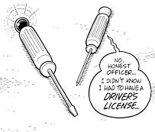
Our Shed is more than just a workshop—it is a family. Every project, cup of tea or coffee, and story shared is a testament to the strength of our community. Until next month—stay safe, stay connected, and keep building!

