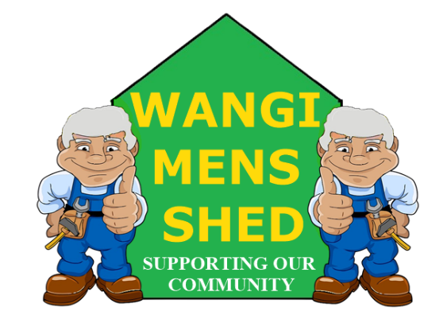
February 2026 Newsletter
  - Connecting Mates, Crafting Purpose

The focus of conversation this month was the proposed closure of Myuna Colliery. The workers at Myuna are important, as are their jobs and families. For decades, these employees have helped power NSW and deserve respect and security, rather than corporate manoeuvring.
Eraring and Myuna began operations together, and they should close together in 2029. The community has supported Origin over the years, so now Origin needs to support this community.
Wang Men’s Shed and Lake Macquarie residents fully back the effort to preserve these jobs.

Shed Happenings
- Amazing turnout at the family fun day to Save Myuna Jobs at Wangi Bowling Club on Sunday 8th February. Over one thousand sausage sandwiches!
- The attendance at the AMSA Cluster Meeting held on Wednesday, February 18th was lower than expected, which was somewhat disappointing, but the leftover pikelets and bacon & egg rolls went down a treat.

Upcoming Events
- Bunnings Morisset BBQ Saturday 21st March.

Member Spotlight
We extend our appreciation to all members who attended in support of the Myuna Colliery workers. We would also like to give special recognition to the team responsible for managing the barbecue. Your dedication and efforts are greatly valued.

Health & Wellbeing
Most of us have heard of menopause and see our partners going through it.
But andropause? That one tends to fly under the radar, usually because blokes just shrug and say, “I’m just tired, mate” and crack on.
As men get older, testosterone levels can slowly drop. For some blokes that can mean things like:
- Feeling flat or grumpy for no apparent reason.
- Low energy (even after a decent night’s sleep).
- Losing muscle or strength, Low libido.
- Brain fog, stress, or feeling a bit off your game.
Sound familiar? You are not alone, and it is not a weakness. The important bit is, do not ignore it.
A simple chat with your GP and a blood test can make a world of difference. Sometimes, it is lifestyle changes, sometimes treatment, but step one is rocking up and asking the question. Looking after ourselves and each other is at the heart of the Men’s Shed ethos. If you are feeling out of sorts or, just need a chat, remember there is always someone here who will lend an ear.

Workshop Safety
You must receive appropriate training on how to use any machinery correctly before operation. PLEASE CONTACT ALAN JONES TO ARRANGE THE NECESSARY TRAINING.
Do not use any machinery, tools, or equipment with an “OUT OF SERVICE TAG.” This tag protects you and the equipment.

New Members Welcome!

Whether you’re experienced or just starting out, you belong here. Feel free to introduce yourself and get involved in our Shed community.

Final Thoughts
An old Irish farmer had a wife who nagged him nonstop. The only peace he had was when he was out ploughing with his mule.
One day she bought his lunch to the field and immediately started nagging him again.
Suddenly, the mule kicked her in the head, and she died on the spot.
At her funeral, the priest noticed something strange: when the women spoke to the farmer he nodded; when the men spoke to him, he shook his head.
Curious, the priest asked why. The farmer said, “The women said how nice my wife looked, the men asked if the mule was for sale.”
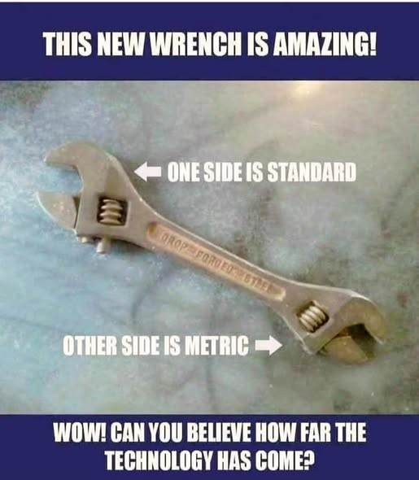
Our Shed is more than just a workshop—it is a family. Every project, cup of tea or coffee, and story shared is a testament to the strength of our community. Until next month—stay safe, stay connected, and keep building!

